LCD display to an Arduino Uno without using I2C

**Components Required**

* Arduino Uno
* 16x2 LCD display (HD44780 compatible)
* 10k ohm potentiometer (for contrast adjustment)
* Breadboard and jumper wires

### Wiring Diagram

Here’s how to connect a 16x2 LCD to an Arduino Uno:

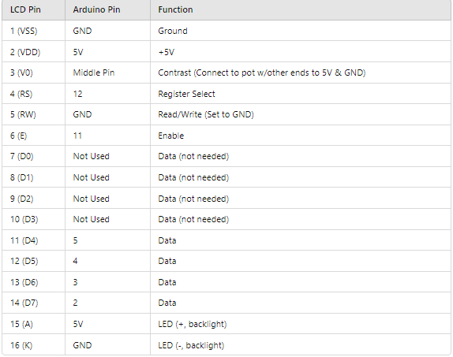

Wiring Notes

Potentiometer: Connect the two outer pins of the potentiometer to +5V and GND. Connect the middle pin to the V0 pin (pin 3) of the LCD to adjust the contrast.

Data Pins: Connect the data pins D4 to D7 to digital pins 2, 3, 4, and 5 on the Arduino, respectively.

Control Pins: Connect RS to pin 12, RW to GND, and E to pin 11.

Code:

#include <LiquidCrystal.h>

// Initialize the library with the numbers of the interface pins

LiquidCrystal lcd(12, 11, 5, 4, 3, 2);

void setup() {

// Set up the LCD's number of columns and rows:

lcd.begin(16, 2);

// Print a message to the LCD.

lcd.print("Hello, World!");

}

void loop() {

// Do nothing here...

}